History of Foam Sclerotherapy—a Review
Angel Angelov, Emil Jordanov, Georgi Angelov, Veselin Petrov
Department of Cardiovascular Surgery and Angiology, Medical University of Varna
Clinic of Vascular Surgery, St. Marina University Hospital, Medical University of Varna
Address for correspondence:
Angel Angelov
Medical University of Varna
55 Marin Drinov St
9002Varna
e-mail: dr_angelov@abv.bg

ABSTRACT
Introduction: Primary varicose veins of the lower extremities mainly cover the great saphenous vein (VSM) and small saphenous vein (VSP) basins. The treatment procedure for pulse removal can be performed by a standard open technique—crossectomy and stripping, by minimally invasive methods—radiofrequency and laser ablation, as well as by internal application of a sclerosing agent in liquid or foam format. The use of foam began as far back as 1939.
Literature Review: This publication examines in detail the historical stages that foam sclerotherapy has gone through from its inception to the present day. The rules for treatment with sclerosing high-viscosity foam, approved by phlebologists worldwide, are described in detail.
Discussion: Foam sclerotherapy for various forms of varicose veins is a uniquely good and inexpensive method for radical treatment of superficial varicose veins. Even if the recurrence rate after foam sclerotherapy is slightly higher than other minimally invasive procedures, foam treatment is an affordable, inexpensive, and highly effective method, as long as it is performed according to the accepted rules.
Conclusion: The present material considers the individual historical moments for establishing the foam treatment as a method of choice. John Bergan’s 2003 statement: “Foam is the future of varicose vein treatment,” is still relevant today.
Keywords: foam sclerotherapy, historical aspects, chemical ablation

INTRODUCTION
The beginning of the treatment of varicose veins of the lower extremities, as well as other diseases, by introducing sclerosant in the form of foam was set in the sixties of the last century by several different, but so far independently working, teams. The main reason for the idea of ​​working with sclerosing foam is dissatisfaction with the results achieved in the treatment of varicose veins with the liquid form of sclerosing agents (39–41).
The types of sclerosing agents, the sclerosing technique, the injection elements, the ultrasound equipment, and the technical parameters of the equipment creating the sclerosing foam are marked as separate building blocks. The excellent combination of all these building blocks gives rise to talk in the medical literature about endovenous chemical ablation or more fully and more precisely about endovenous non-thermal ablation of varicose veins (14,40).
Over the last 20–25 years, thanks to a number of clinical studies, technical improvements and several international consensus solutions, a significant improvement in the effectiveness of foam treatment has been achieved, and the security of this method has been strengthened. Modern means of communication today allow rapid discussion among teams around the world, something impossible half a century ago.
Not only medical publications in various phlebologic sources are important for the progress in the treatment of varicose veins with foam but also the real achievements in the application of foam treatment in other fields of medical science. This review presents the individual technical building blocks, as well as the purely clinical aspects of sclerosing foam treatment, which are a practical guide for all colleagues using this type of ablation technique (14,40).
REVIEW OF THE MEDICAL LITERATURE
1. Liquid sclerosing substances

It is known that the first injection in humans was made by Elsholz (1623–1688), but the first injection of a sclerosing agent was made by Zollikofer in 1682. The French surgeon Charles Gabriel Pravaz (1791–1853) is known in the history of medicine for developing a small syringe, the plunger of which could move slowly forward by means of a rotating mechanism, which led to a more accurate dosing of drugs. With the help of a specially sharpened needle, it was now possible to inject the drugs directly into the vein without the need for prior detection by a skin incision. Pravaz developed various types of metal and glass syringes, which he himself later used to introduce sclerosing agents in liquid form. In fact, the world’s first sclerosis was performed by him. He introduced iron-3-chloride into an arterial aneurysm (14).
In the following years, in their desire to find the most suitable sclerosing substance, scientists tested a variety of chemical substances, which were later combined under the common name of detergents—sclerosing drugs (14).
Sodium morrhuate is the oldest member of this group, which was first used as a sclerosing agent by Higgins and Kittel in 1930. Only a few years later, in 1937, Biegeleisen published its results on the application of the sclerosing agent ethanolamine oleate (40,41).
In 1946, Reiner developed and introduced into clinical practice the chemical agent sodium tetradecyl sulfate, known under the trade name Fibrovein. Exactly twenty years later, Henschel in Germany published his own first results from the molecule he created, the substance Polidocanol. It appears on the market as a detergent called Aethoxysklerol. The success of this preparation was phenomenal and it quickly spread throughout the world. It is known that since 1966 there have been no publications on the development of other sclerosing agents that are superior to Polidocanol. During the National Phlebological Conference in Germany in 2007, it was announced that more than 240 million ampoules had been produced to date, treating more than 80 million patients worldwide (14).
First in the world, in 1939 McAusland (18) applied the treatment of varicose veins with a sclerosing agent in the form of foam. The substance he first used to treat varicose veins was sodium morrhuate. McAusland created the “foam” by vigorously shaking the liquid in a sealed bottle, which also had a rubber stopper inside. He then aspirated the foam into his syringe and injected it intravenously. Since it is known that only substances with detergent action are able to turn into foam, it becomes clear why before their creation as chemicals, i.e. before 1930, no one could turn liquid sclerosing substance into foam (18).
Thanks to his own observations, McAusland has established the advantages of sclerosing foam over liquid sclerosing agents, as well as better end results. His words were: “In the treatment with foam it is better to follow the movement of the substance along the veins.” From 1944 he began to use the substance ethanolamine oleate to produce sclerosing foam (14,18).

2. Attempts to create sclerosing foam
Historically, foam was offered as a healing procedure long before 1939, when foam sclerotherapy began being implemented in the world. Foam has been used to treat many pathological conditions, such as skin burns, and even to put out fires. As far back as 1929, new engineering technologies were described for the rapid mixing of soap solutions with atmospheric air or other gas, which resulted in finely dispersed foam used in firefighting. Wilmsmann patented in 1964 a device in which foam is obtained by the rapid rotational movements of a brush with artificial hair immersed in a solution of detergents (36,37).
Since 1979, scientists have been working on the problem of the stability of different types of sclerosing foam, its half-life, as well as the correct ratio of liquid detergent to the corresponding amount of air or other gas. In the same year, Cunnigham published his findings on this issue (5).
In 1989, Poizot patented a device in which the mixing of gas and liquid takes place by means of an extremely fine filter with a pore size of 10 to 250 µm. And this author emphasizes the fact that foam treatment is better and more controllable (23).
Along with the pioneers in the application of the foam sclerosing technique, the treatment of varicose veins with liquid sclerosing substances is constantly improving. For example, in 1944, Orbach came up with an idea, which was unique for his ​​time, that the results were much better when the sclerosing substance had greater and longer contact with the endothelium and was not allowed to be diluted too much with blood. He introduced into clinical practice the technique of pre-injection of up to 3 mL of air, and immediately after—the sclerosing substance. He calls this technique Airblock Technique (20–22).
Stemmer and co-authors published an article in 1970 describing that Airblock Technique was suitable for veins with a caliber of up to 4 mm. For larger vessels, and especially for those vessels with a diameter of more than 8 mm, it has the opposite effect—the introduced air does not empty the vein from the blood, moreover, it prevents the direct contact of the sclerosing molecules with the endothelial cells (33).
In the same year that Orbach’s publication appeared, Robert Rowden Foote’s monograph was published in London (14). On the treatment of paniculate veins with a sclerosing agent, he wrote: “The best treatment method is the foam obtained by shaking 1 mL. ethanolaminoleate with air in a two-cubic syringe. Once the tip of the needle is already in the vein, the movement of the bubbles in the vessel can be visually observed” (9). From a modern point of view, it can be said that the 1:1 ratio of sclerosing substance and air introduced by Foote would more likely lead to the formation of a dispersion than to a foam. Because the dispersion is more fluid than the foam, it is unable to push blood out of larger diameter veins to make better contact with the endothelium.
In 1949, Karl Sigg adopted the Airblock Technique described five years earlier. He used it mainly to remove large diameter varicose veins and published results from over 4,000 absolutely problem-free treatment procedures. He even came to the conclusion that instead of air, foam could be introduced into the already punctured vein, followed by the sclerosing agent itself (32).
A few years later, Karl Sigg published the results of combining Orbach’s Airblock Technique with Foote’s: “Foam washes the blood in the varicose vein more easily and quickly than clean air” (32).
In 1950, Orbach published an article in which he himself analyzed the results of treatment with liquid sclerosant, comparing them with those in the application of foam. He described that the foam gave 3.5 to 4 times better treatment results. In addition, he found that with foam the venous spasm was significantly larger and longer (21).
In 1953, Ree published data on 50 successfully cured patients with sclerosing foam. He applied it in the ratio: on 6.6 mL of air 2 mL of sclerosing agent, and the foam was obtained by vigorous shaking of the ampoule. He then aspirated the bubbles and immediately introduced them into the vein (29).
Flückiger has made significant progress in the treatment of sclerosing foam. Instead of the hitherto known antegrade sclerosis, in 1956 he introduced retrograde sclerosis into clinical practice. The tip of the needle is already pointed distally in the direction of the patient’s fingers. He found that the antegrade injection of foam diluted much faster with the flow of blood coming from the distal veins and less into the lateral branches. When retrograde sclerosis is performed, the thinning of the foam is less, the foam enters more lateral vessels and gives better results from the therapy. And another advantage: in retrograde sclerosis, the foam moves both to the fingers of the limb and proximally; thus a larger area is covered, while in antegrade sclerosis the movement of the foam is only in the direction of the outflow of venous blood (7).
Flückiger became famous with two more moments. He was the first in the world to find that the smaller the diameter of the foam bubbles, the better their contact with the endothelium and the better the resulting endothelial desquamation. His thought is: “The best prerequisite for the success of the treatment is the creation of a homogeneous sclerosing foam with extremely fine bubbles” (7,8).
Flückiger got acquainted with all the known ways to obtain foam. He proved that they were not suitable for creating bubbles with a small diameter and proposed his original method. He very carefully dipped the beveled tip of the needle with the syringe to only 2/3 of the liquid level in the ampoule. The remaining 1/3 was above the level. Upon subsequent aspiration through the plunger, a characteristic sound was heard in the syringe—liquids and air were automatically mixed, resulting in a fine stable foam that retained its properties for several minutes (7,8).
The cornerstone in the standardization of sclerosing foam was a publication by Mayer and Brücke in 1957 (17). The patent syringe with a double plunger—in front of the standard plunger a second one with a repeatedly perforated surface was included. This additional piston moved in the cylinder of the main piston. Thus, during the rapid movement of the second piston, the liquid, which was ethanolamine oleate, was mixed with the air in the syringe. A very high quality fine viscous foam was obtained. After the clinical application of this drink, the authors wrote: “We have not observed anyone with skin necrosis and air embolism in the application of this foam for the treatment of varicose veins” (17).
Nevertheless, in 1962, Flückiger published his method for producing quality and viscous foam: a syringe with a needle in which air was aspirated, which was added to the vial of sclerosing substance; this system is turned vertically with the vial above the needle syringe (7). When the piston moves in both directions, a very fine foam, resembling white cream, is obtained. Flückiger also made additional announcements to his first publication in 1956.
He recommends elevation of the limb, as it should not be done only during the injection of the foam. This sloping position should be maintained for a few more minutes until the complete decomposition of the foam. The author finds that declivity helps the foam to be directed to the periphery—the fingers. In addition, it reduces the likelihood of some of the foam entering the deep venous system (7). At present, we know very well that in the treatment of foam the limb is placed in a sloping position—the foot with the toes is at 45º, there is a wait of about 5 minutes before compressing and massaging the treated vein (1,14).
However, the proposals for creating viscose foam do not end there. In 1969, Gillesberger proposed a negative pressure syringe that instantly produced foam when aspiration of the sclerosing agent was started (10). And in 1984, Hauer’s patented model was recognized: in a closed chamber, two parallel-inserted syringes were emptied simultaneously—one with liquid sclerosant, the other with air (13). Foam was immediately formed in this chamber, which was already aspirated with one syringe. And in 1986, Grigg connected two syringes 180 degrees apart: one with sclerosing fluid and the other with atmospheric air. The two syringes were connected by a thin plastic hose. When the two pistons moved simultaneously, turbulence was created, which turned the liquid into foam (14).
All these attempts to create better quality foam were until 1986, i.e., before the introduction of echo-Doppler methods in phlebology.
3. Foaming using atmospheric air or other gases
It has already been mentioned that the first doctor in the world to inject foam intravenously for therapeutic purposes was McAusland. But how much air he used to make his foam is still unknown. Later in time, Orbach proved that intravenous injection of small amounts of air without pre-created foam—only up to a few milliliters—was not dangerous for the patient (20–22).
Mayer and Brücke published a report in 1957 that intravenous injection of up to 40 mL into the varicose veins of the lower extremities did not cause air emboli and strokes (17). At the same time, scientists were working to introduce other gases into clinical practice for better contrast in radiology. Durant, Oppenheimer, and others also found in 1957 that intravascular injection of carbon dioxide better visualized intracardiac structures and coronary vessels. Thus, thanks to their developments, today we enjoy the success of CO₂ angiography, which is used in patients with a proven allergy to standard contrast agents (6).
In 1990, Hess’s publication was published, in which he categorically rejected the introduction of atmospheric air into the human body due to the standard presence of a large percentage of nitrogen, which is difficult to dissolve in biological fluids. He proved that the biological gases oxygen and carbon dioxide have a much better solubility (11). Based on his developments, Cabrera introduced into clinical phlebological practice in 1994, instead of atmospheric air, the gases oxygen and/or carbon dioxide—separately or in different ratios (4).
And in 1999, Garcia Mingo was the first to publish a report on the use of noble gases to produce sclerosing foam. His first development was with helium. His patented device is called the Foam Medical System (14).
4. The introduction of ultrasound Doppler devices in phlebology
The introduction of B-mode technology of ultrasound equipment has led to real progress in phlebology. Barber was the first to report the use of an ultrasound Doppler in 1974 for diagnostic phlebological purposes (2). And it was not until 1989 that Knight, Vin, and Zygmunt were the first in the world to publish a report on the use of an ultrasound machine to inject a sclerosing agent (15). Their main purpose was to improve the safety of sclerosing treatment, to stop the so-called “blind” venous puncture and to prevent the risk of misdiagnosis of intra-arterial sclerosant. They proved that tracing the tip of the needle helps for accurate intravascular injection, as well as prevents possible paravasal application. All their developments are still relevant today and are included in the main guidelines (14).
In 1993, Michael Schadeck made another significant progressive step in phlebology. He mixed detergent with atmospheric air and found that these small bubbles in the vessel were an excellent contrast agent (31). The ultrasound probe perfectly traced the movement of sclerosing foam through the venous vessels from the injection site in the proximal direction. In June 1994, Juan Cabrera applied for a patent for his “injection foam” (4). A year later, he presented his first results from the treatment of varicose veins with this foam under constant ultrasound control. But it did not reveal how to prepare its “injection foam”. Historically, his name has been associated with pioneers who offered and performed sclerosing treatment using constant real-time ultrasound monitoring (14).
In 1999, Cabrera patented another way to make sclerosing foam. He used a dental polisher; a brush was attached to it, which rotated from the electric motor of the device at 8000 to 12000 revolutions per minute. The brush was immersed in a cylindrical tall bottle with a sclerosing agent. Carbon dioxide and/or oxygen were supplied to it. The rotational movements of the brush mixed the liquid with the gas and a sclerosing foam was formed (14).
5. Modern methods for preparation of sclerosing foam
In 1997, Alain Monfreux came up with his original idea for sclerosing foam: his liquid sclerosant syringe was sealed with a sterile stopper and had a small gap in the plunger. As the piston moved in the opposite direction of the plug and back from the gap, a small amount of air entered, which turned the liquid into foam. This method was then quickly adopted by French phlebologists (19). Nevertheless, in the same year in Germany, Gillesberger proposed his own method, similar to the French. Two years later in Italy, a team consisting of Sadoun, Benigni, and Sandos Gaston presented their own versions of the sclerosing technique offered by Monfreux (30).
In 1999, two more interesting ways to create highly viscous foam were published. The first was associated with the name of Javier Garcia Mingo. It mixed helium or carbon dioxide with liquid sclerosant in a closed system, thus increasing the pressure inside. This mixture left the closed system through an opening of very small diameter in the form of sclerosing foam. It was aspirated and injected into the patient’s vein (14).
In December of the same year, Lorenzo Tessari proposed a completely new method, which is still relevant today. This is the method with the two syringes and the three-way tap between them. There is atmospheric air in one syringe and a sclerosing agent in the other. The synchronous movement of the two pistons in the three-way valve creates turbulence, which produces sclerosing foam. Shortly afterwards, Tessari found that if he placed the tap in a semi-open state, the diameter of the gap in the tap, where the liquid and atmospheric air passed, became smaller, which significantly improved the quality of the sclerosing foam. For the first time in the world, an extremely fine high-viscosity creamy foam was obtained (34). The method was quickly adopted throughout Italy, and even in 2001 the relevant guidelines were published to standardize the rules for creating this foam (14).
In 2000, Trinidad Vazques Magdiel developed a special device for creating sclerosing foam by directing oxygen to the liquid from a detergent through a filter. The resulting foam was deposited on a membrane from which it is aspirated with a syringe (14).
It was found that until 2000, all attempts to create sclerosing foam showed the same drawback—the inability to reproduce foam with the same parameters. Each new foam had a different consistency from the previous one and different homogeneity. Therefore, scientists have begun looking for ways to create foam with good reproducibility, new ways and methods that are close to the proposed technique of Tessari. In the laboratory, the focus was mostly on foam with better stability. The scientists’ experiments were focused on the most correct ratio of liquid and gas, the size and type of syringes, the type of connecting element between them, the size of the nozzle, etc. As the best way to obtain sclerosing foam, the use of two 10 mL syringes was proposed, in one of which 8 mL of air is aspirated through a sterile filter with pores of 0.2 µm, and in the other—2 mL of sclerosing substance. Both syringes must be luer-lock and connected to a suitable adapter. They are located in one plane—opposite each other. In the beginning, only one plunger is used—the syringe with liquid: it is pressed five times against resistance. This mixes the liquid with the sterile air. The resulting 10 mL of foam is then transferred in successive pumping movements from one syringe to the other. Finally, a well-homogeneous high-viscosity sclerosing foam is obtained (14,39,40,41). In the scientific literature, this method is described as DSS—Doppelspritzensystem—a system of double syringes, or as Tessari-DSS (40).
In 2001, Gachet published his method for creating sclerosing foam, which in principle closely resembles the Flückigers methodology of 1956 (14).
In the same year, a third European patent was issued to the team of Harman, Pollock, and co-authors for their development: two vessels, one with liquid—detergent, and the other with compressed air, are connected by a narrow gap. When air passes from one vessel to another, where the liquid is, a highly viscous foam is obtained (12).
In 2001, a newly created computer-mechanical device developed by Hamel and Desnos was reported. These scientists, together with colleagues, launched a prospective randomized study in patients with stem varices of the saphenous vein. They compared the results of the applied treatment with 3% foam with the results in patients who received standard treatment with 3% liquid sclerosant (14).
In 2002, doctors Wollmann and Schliephake, who worked in Wiesbaden for the manufacturer of sclerosing agents Kreussler, proposed their own method for mixing sterile air with a sclerosing agent, placing the liquid in a special cartridge. Work was underway to address the identified shortcomings of this system, and in 2005 a significantly improved version of the Tessari-DSS system was published for the first time. It's called EasyFoam. The first novelty is the use of special syringes with low silicone content. Second: the amounts of gas and liquid on the scales of the two syringes are precisely determined (Figs. 1 and 2).

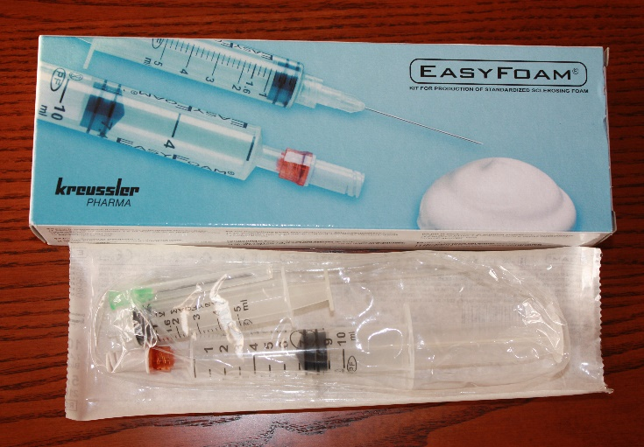
Fig. 1. Ready-made kit with silicone-poor syringes, one of which is with sterile air

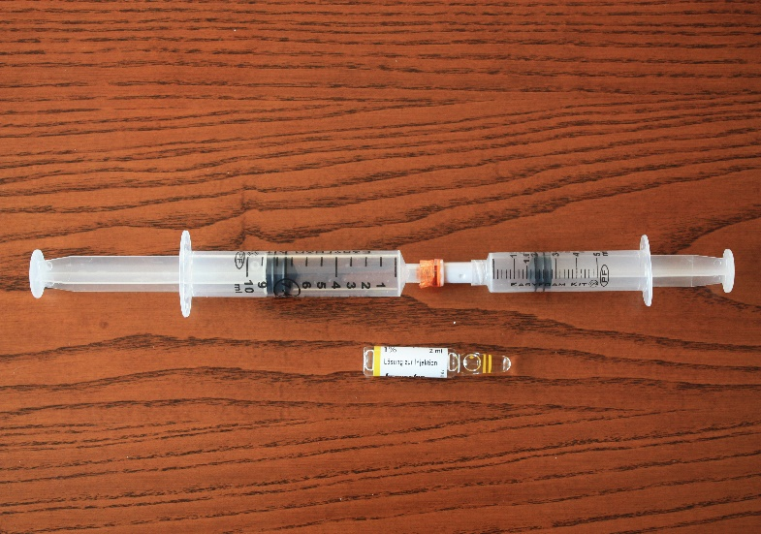

Fig. 2. Articulated syringes with 7.4 ml sterile air and 1.6 ml sclerosing agent
It was found that when complying with the ratio of 7.4 mL of gas:1.6 mL of liquid, the resulting foam has the highest qualities. EasyFoam is available with sterile air in one syringe. The resulting foam has a high viscosity and greater stability (Fig. 3 and 4).
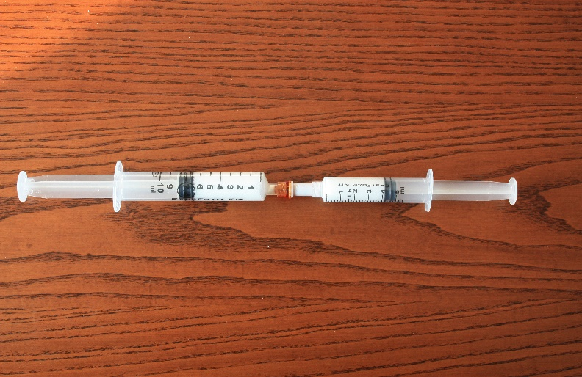
Fig. 3. 10 mL of foam is divided into the two syringes

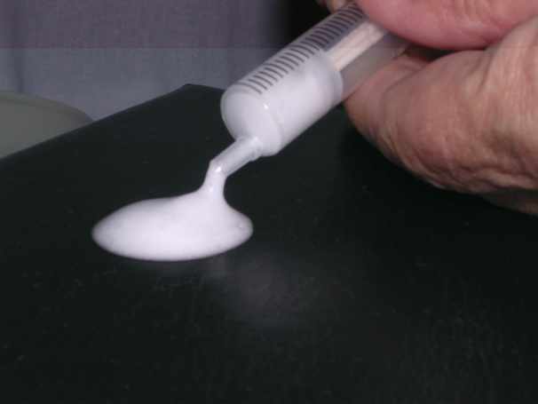
Fig. 4. Foam with high viscosity and stability
The fourth novelty is the special adapter that connects the two syringes (Fig. 1, 2, and 3).
This system has been tested in the following years in several randomized clinical trials and has been shown to be effective (14). It is currently considered to be the method of choice in the preparation of foam for sclerosing treatment.
CONCLUSION
With the introduction of the method of foam sclerotherapy, significant successes have been achieved in the sclerosing treatment of varicose veins. It is possible in the near future for new more advanced methods to be proposed and validated in clinical practice. For now, however, foam sclerotherapy is the cheapest and most profitable method for radical treatment of varicose veins (3,16,24–28). Provided that it is performed according to the rules, the success rate is over 95% and the chance of recurrences is minimized. At the Phlebological Congress in Bologna in 2003, John Bergan openly stated: “Foam is the future of varicose vein treatment” (14). His conclusion is still valid today.

References
- Angelov A, Endovenous laser ablation of trunk varicose veins. Monography. Medical University -Varna, 2019, 65-70, 84-88, 121-125
- Barber F, Baker D, Nation A et al: Ultrasonic duplex echo-Doppler scanner. IEEE Trans. Biomed Eng 1974; 21: 109.
- Breu FX, Guggenbichler S, Wollmann JC, 2nd European Consensus Meeting on Foam Sclerotherapy, 28-30 April 2006, Tegernsee, Germany. Vasa 2008, 37(71): 1-32.
- Cabrera Carrido J, Cabrerea Garcia-Olmedo J, Injectable micro foam containing a sclerosant agent. European Patent Office, EP 656203A1; 21.06.1994.
- Cunningham CJ, Method and apparatus for producing foam, European Patent Office, EP 11381A, 16.10.1979
- Durant TM, Stauffer HM, Oppenheimer MJ, Paul RE, Safety of intravascular carbon dioxide and the use for roentgenology visualization of intracardiac structures. Ann Int Med, 1957; 47:191-201.
- Flückiger P. Beitrag zur Technik der ambulanten Varizenbehandlung. Die med Welt 1963; 12:617-621.
- Flückiger P. Nicht-operative retrograde Varizenverödung mit Varsylschaum. Schweiz Med Wochenschr 1956; 48:1368-1370.
- Foote RR, The injection treatment. London: HK Lews&Co. Ltd., 1944; 13-44.
- Gillesberger W. Die Ausrüstung der phlebologisch tätigen Dermatologen. Z Hautkrankheiten 1969; 44:669-674.
- Hess H. Digitale Subtraktionsangiographie mit Kohlendioxid: eine Alternative zur Extremitätenangiographie mit jodhaltigen Kontrastmitteln. Fortschr Röntgenstr. 1990;153:233-238.
- Harman AD Harper PV, Pollock N, Sinclair GS, Generation of therapeutic microfoam, European Patent Office EP 13372338B1; 23.11.2001.
- Hauer G. German Patent DE 34 17 182 C2. Zwillings-Spritzen-Set. 1984.
- Hübner K, Praktische Sklerotherapie, 2008, 142-160, 164-185.
- Knight RM, Vin F, Zygmunt JA, Ultrasonic guidance of injection into the superficial venous system, Phlebology 1989; 339-341.
- Kressler: Fachinformation Aethoxysklerol 0,25%, 0,5 %, 1 %, 2 % und 3 %; Stand Oktober 2009, Chemische Fabrik Kreussler & Co GmbH.
- Mayer H, Brücke H. Angiologie - Zur Ätiologie und Behandlung der Varizen der Unteren Extremitäten. Chir Prax 1957; 4:521-528.
- McAusland S. The modern treatment of varicose vein. Med Press Circular 1939; 201: 404-410.
- Monfreux A. Traitement sclerosant des troncs sapheniens et leurs collaterals de gros calibre par la methode mus. Phlebology 1997; 50:351-353.
- Orbach EJ, Sclerotherapy of varicose veins – Utilization of an intravenous air block. Am J Surg 1944; LXVI(3): 362-366.
- Orbach EJ, Petretti AK. The thrombogenic property of foam of a synthetic anionic detergent. Angiol 1950; 1:237-243.
- Orbach EJ, Contributions to the therapy of varicose complex. J INT College Surgeons 1950; 6:765-771.
- Poizot E, Device for producing foam, European Patent Office, EP 379818A1, 21.12.1989.
- Rabe E, Otto J, Schliephake D, Pannier F Efficacy and safety of great saphenous vein sclerotherapy using standardized polidocanol foam (ESAF): A randomized controlled multicenter clinical trial. Eur J Endovasc Vasc Surg 2008; 35:2238-2245.
- Rabe E, Pannier F, Gerlach F, Breu FX., Guggenbichler S., Wollmann JC., Leitlinie Sklerosierungsbehandlung der Varikose, Phlebologie 2008; 37:27-34.
- Rabe E, Pannier-Fischer F, Gerlach F. et al. Guidelines for sclerotherapy of varicose veins. Dermatol Surg 2004; 30:687-693.
- Rabe E, Schliephake D, Otto J, Breu FX, Pannier F: Sclerotherapy of telangiectasis and reticular veins : a double-blind, randomized comparative clinical trial of polidocanol, solidum tetradecyl sulphate and isotonic saline (EASI study). Phlebology 2010; 25:124-131.
- Rabe E, Gerlach F, Breu FX, Guggenbichler S, Stücker M, Pannier F, Leitlinie: Sklerosierungsbehandlung der Varikose, Phlebologie 2012; 4:3-10.
- Ree A. Etamolin foam in the treatment of varicose veins. A new method. Acta Dermatovenerol. 1953; 33:435-436.
- Sadoun S, Benigni JP, The treatment of varicosities and telangiectases with TDS or lauromacrogol foam: video tape: UIP World Congress of Phlebology, Sydney, 1998.
- Schadeck M. Echosclerose de la grande Saphene. Phlebologie 1993;46:673-682.
- Sigg K, Neuere Gesichtspunkte zur Technik der Varizenbehandlung. Ther Umsch 1949; 6:127-134.
- Stemmer R, Kopp C, Voglet F, Physikalische Studie der Sklerosierungsinjektion, Zentralbl Phlebol 1970; 9(2): 112-123.
- Tessari L, Cavezzi A, Frullini A, Preliminary experience with a new sclerosing foam in the treatment of varicose veins. Dermatol Surg 2001; 27:58-60.
- Waldschmidt E, Device for producing foam. Unite States Patent Office, US 2043599A, 09.06.1936
- Wildenhues B. Catheter assisted foam sclerotherapy: A new minimally invasive method for the treatment of the trunk varicose of the long and short saphenous veins. Phlebology 2005; 34:165-170.
- Willsmann H. Schaumbestimmung von Tensiden mit einer Reibschaummethode. Fette, Seifen, Anstrichmittel, 1964,66,11, 955-961
- Wollmann JC, Die Geschichte der Sclerosierungsschäume, Praktische Sklerotherapie, 2008, 142-149.
- Wollmann JC, Herstellung und Eigenschaften von Sklerosierungsschaum, Vasomed 2004; 16,1:24.
- Wollmann JC, Schaum – zwischen Vergangenheit und Zukunft, Vasomed 2002; 16:34-35.
- Wollmann JC, The history of sclerosing foams, Dermatol Surg 2004; 30:694-703.
Адрес за кореспонденция:
Доц. д-р Ангел Ангелов, дм
Медицински университет
Варна 9002, ул. „Марин Дринов“ № 55
dr_angelov@abv.bg

