Thoracoscopic Techniques in the Diagnosis and Surgical Treatment of Pleural Effusions—Advantages and Disadvantages of Different Thoracoscopic Approaches

Katerina Marinova

Clinic of Thoracic Surgery, St. Marina University Hospital, Medical University of Varna

Address for correspondence:
Katerina Marinova
St. Marina University Hospital
1 Hristo Smirnenski Blvd
9010 Varna
e-mail: kate_marinova@hotmail.com

ABSTRACT

Introduction: Pleural effusions are among the most commonly encountered conditions in the field of thoracic surgery. There are numerous diagnostic and treatment options, but the timing and precise choice of intervention remains critical.
Aim: The aim of this article is to present and discuss the advantages and disadvantages of various thoracoscopic approaches in the diagnosis and radical treatment of pleural effusions.
Materials and Methods: From 2012 to 2022, 325 patients with pleural effusions were treated in our clinic using video-assisted thoracic surgery (VATS) techniques. Of these, 207 were male and 118 were female, aged between 15 and 88 years. The type of surgical access was selected based on the nature of the effusion—etiology, free or localized, radiographic findings, patient habitus, and our desired surgical volume.
Results: Video-assisted thoracic surgery was used in 325 patients, with 173 having inflammatory and 152 having malignant effusions—primary and metastatic. A three-port approach was used in 27 patients, a two-port approach in 193, and a one-port approach in 105. The indications, contraindications, advantages, and disadvantages of each thoracoscopic approach were discussed, allowing for individualized treatment approaches and improved outcomes for each patient.
Conclusion: The personalized choice of a specific thoracoscopic approach and technique in the treatment of pleural effusions is a crucial step in achieving the best results for each patient.
Keywords: pleural effusion, VATS, advantages and disadvantages

INTRODUCTION

Pleural effusions are among the most commonly encountered conditions in the field of thoracic surgery. There are numerous diagnostic and treatment options, but the timing and precise choice of intervention remains critical. A pleural effusion involves the excessive accumulation of fluid in the pleural cavity, hindering the function of the lung. From a pathophysiological standpoint, this is due to an imbalance in normal fluid dynamics caused by increased production or inadequate reabsorption. The normal rate of this interrelated process is 0.01 to 0.02 mL/kg/hour or 5 to 10 liters of fluid every 24 hours.

Historically, pleural effusions have been a challenge for physicians since their first description over 3000 years ago by Imhotep in ancient Egypt. In the 19th century, effusions were primarily treated with open drainage until the discovery of closed pleural drainage in 1876. This method of treatment was widely accepted and used during the later influenza epidemic of 1917–1919 (3, 7).

The etiology of pleural effusions is linked to their formation as a result of various local and systemic pathological processes:
- General pathological processes:
They involve disruptions in electrolyte or protein balance, observed in conditions such as heart failure, renal insufficiency with nephrotic syndrome, hypoalbuminemia, and others.
- Local pathological processes:
They involve actions at the local level, associated with increased permeability of pleural capillaries, elevated pressure within them, disrupted lymphatic drainage, and increased negative pressure in the pleural cavity.
- Mixed genesis:
It results from the influence of more than one mechanism.

The classification of pleural effusions is based on their nature, type, localization, and etiology. Generally, they are divided into benign and malignant. Depending on their cause, they can be inflammatory (associated with bacterial, viral, fungal, and parasitic diseases), neoplastic, effusions in cardiovascular diseases, collagen disorders, sarcoidosis, effusions in diseases of the abdominal organs, lymphatic system, post-traumatic effusions, drug-induced, and other rare variations. Pleural effusions can be unilateral or bilateral. Based on their macroscopic appearance, effusions are categorized as serous, serofibrinous, fibrinous, hemorrhagic, purulent, lipid-rich, etc. In terms of localization, they can be free or encapsulated, situated interlobarly, mediastinally, diaphragmatically, or at the periphery. Pleural effusions, based on their nature, are mainly classified as transudates and exudates.

In recent years, with the advancement of minimally invasive techniques, there has been a shift in traditional approaches to the diagnosis and treatment of pleural effusions. There is a growing tendency to use thoracoscopic access more frequently than conventional surgical techniques. This shift is motivated by the desire to reduce hospital stay, minimize the intense post-thoracotomy pain with all its unpleasant consequences (such as restricted breathing, secretion retention, atelectasis, infiltrates), the need for broad medication, and the potential for a less favorable cosmetic outcome.

Video-assisted thoracic surgery (VATS) techniques contribute to a comprehensive solution to the issue of pleural effusion. They offer an individualized approach based on the specific type of effusion and the patient’s condition. This approach aims to address the challenges associated with traditional methods, providing a more patient-friendly experience and improving overall outcomes.

MATERIALS AND METHODS:
During the period from 2012 to 2022, 325 patients with various types of pleural effusions were diagnosed and treated using minimally invasive VATS techniques at our clinic. Among them, 207 were male and 118 were female, with ages ranging from 18 to 88 years and an average age of 64.5 years.

For all patients, a 10-millimeter, 30-degree optics from the Olympus system were used. In cases with significant adhesions, existing loculations, or during decortication procedures, a harmonic scalpel from Ethicon was utilized. Indications and contraindications for surgical treatment of pleural effusions in our clinic were systematized as outlined in Table 1.

Indications | Contraindications
Small pleural effusions unresponsive to conservative treatment | Patients in a severely impaired general condition (inoperable patients)
Massive pleural effusions | Patients with a single lung
Malignant pleural effusions with an unclear primary focus and suspicion of a tumor, located in the organs in the chest and to achieve a histological diagnosis | Patients who cannot tolerate separate intubation anesthesia with accompanying diseases of a local nature—COPD, pulmonary fibrosis, etc.
Malignant pleural effusions for the purpose of talc pleurodesis | Patients with non-massive pleural effusions of proven cardiac, renal, or hepatic origin
Chronic stage of pleural empyema for decortication | Patients with multiple concomitant diseases of a systemic nature who cannot tolerate general anesthesia
Chronic-recurrent pleural effusions of unknown origin
Loculated or multiseptate pleural effusions
Complicated inflammatory pleural effusions and purulent pleural effusions
Chylous effusions for the purpose of intervention on the thoracic duct
Hemorrhagic pleural effusions

Table 1. Indications and contraindications for surgical treatment of pleural effusions.

Surgical Approach Selection
The choice of surgical access was based on the nature of the effusion, including its etiology and associated pathology, whether it was free or localized, radiographic findings, patient habitus, and the desired surgical volume.

Investigated Parameters
The study examined the preoperative period, operative time, postoperative period, overall hospital stay, time of drain removal, intra- and postoperative complications, and comprehensive outcomes in terms of both diagnostic and therapeutic aspects.

RESULTS:
Video-assisted thoracic surgery techniques were employed in a total of 325 patients. Among them, 173 had inflammatory and 152 had malignant effusions—primary and metastatic. A three-port approach was used in 27 patients, a two-port approach in 193, and a one-port approach in 105 (Table 2).

Surgical Approach | Number of Patients | %
Multiportal | 27 | 8
Biportal | 193 | 60
Uniportal | 105 | 32
Total | 325 | 100

Table 2. Performed operations with different thoracoscopic approaches.

DISCUSSION:
The advantages and disadvantages of each specific thoracoscopic approach have been discussed, allowing for the individualization of the approach and treatment to improve outcomes for each patient. Table 3 summarizes the results for the patients who underwent surgery with the three types of thoracoscopic approach and the parameters that were investigated during these interventions.

Approach | Multiportal | Biportal | Uniportal
Number of patients | 27 | 193 | 105
Intraoperative time | 45–112 min | 30–90 min | 40–100 min
Hospital stay | 3–12 days | 3–9 days | 3–8 days
Intraoperative complications | N/A | Bleeding from an interlobar vessel (1) | N/A
Postoperative complications | - Persistent leakage after decortication (6)  - Arrythmia (1) | Persistent leakage after decortication (6) | - Persistent leakage after decortication (4)  - Suppuration of the operative wound (1)
Time to remove the drain | 2–10 days | 2–7 days | 2–7 days

Table 3. Summary of results for parameters with different thoracoscopic approaches.

DISCUSSION
There are various algorithms for the comprehensive examination, assessment, and treatment of pleural effusions. Sometimes, despite extensive investigations, certain patients are either left undiagnosed or diagnosed under the category of non-specific pleuritis. Venekamp and colleagues conducted a retrospective study demonstrating that, among 75 patients initially assessed as having non-specific pleuritis, 8.3% were later diagnosed with malignant diseases during a 2-year follow-up (7, 10). Such studies underscore the significance of VATS in refining the diagnosis and treatment of pleural effusions by enabling thorough examination and targeted biopsy of suspicious areas, as well as facilitating prompt therapeutic intervention in cases of unequivocal malignancy through procedures like talc pleurodesis. The effectiveness of VATS techniques in diagnosing and treating malignant pleural effusions has been extensively studied in recent years, confirming good tolerance, safety, and significant benefits, especially when talc pleurodesis is performed. The economic benefits of VATS in such cases are also discussed (8).

Video-assisted thoracic surgery is increasingly being utilized for pleural inflammation in complicated effusions and even in the early stages of empyema as an alternative to open techniques, yielding comparable results in terms of good visualization, thorough pneumolysis, and debridement. Early operative treatment demonstrates much better chances of cure compared to conservative therapy or standalone drainage, especially when combined with fibrinolytic therapy (12, 13). Several studies confirm the positive outcomes of using VATS in complicated parapneumonic effusions and pleural empyema, showcasing it as an effective and safe procedure. When applied early in the treatment strategy, VATS leads to shorter hospital stays and lower overall treatment costs (6, 11). Minimally invasive techniques are increasingly employed in patients with infection in the later stages, coagulation disorders, or other accompanying diseases categorized as high-risk for open decortication (9). In such cases, comorbid and intoxicated patients show significantly faster recovery with thoracoscopic techniques, causing less trauma to the chest wall and shorter intraoperative time (less time under general inhalation anesthesia). Early thoracoscopic treatment is often sufficient and a prerequisite for avoiding extensive open surgeries, which also favors faster recovery, shortens the hospital stay, and reduces costs (1).

It is essential to note that multiple factors influence the success of VATS decortication, including the duration of disease development, prior treatment, the experience and capabilities of the operator, the availability of specific instrumentation, and effective collaboration with other specialists involved in the treatment process, particularly anesthesiologists. In cases of unsatisfactory results or recurrence, there should be no hesitation toward conversion. Several studies emphasize the significance of infrequent recurrences or re-interventions in specific and complicated cases of empyema, especially in post-pneumonectomy cases (14). Therefore, open decortication is still considered the gold standard in treating empyema with proven trapped lung (Fig. 1). It is crucial to highlight that for a successful VATS decortication, the timing of the surgical intervention after the organization phase but before fibrothorax formation holds great importance for achieving a good final result and the restoration of normal lung function and breathing mechanics (2).

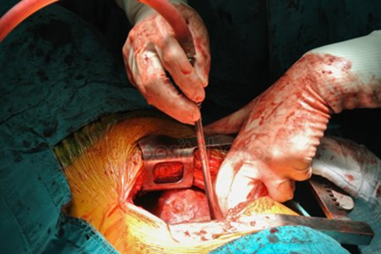

Fig. 1. Open decortication.

In our clinic, all three standard types of thoracoscopic approaches are utilized: uniportal, biportal, and tri- or multiportal, along with their modifications for anterior and posterior access.

The main advantages of the classic multiportal approach include:

1. Access to all anatomical areas in the chest: Particularly crucial when dealing with solitary loculations in challenging-to-reach areas.
2. Use of standard thoracoscopic instruments: These are more affordable and readily available for most centers.
3. Greater involvement of assistants: In contrast to other approaches where assistants are often confined to the role of a cameraman.
4. Technical ease in performing effective decortication: Easier control of bleeding.
5. Better selection of ports for chest tube placement: Facilitating easier placement and optimal declivitous positioning.
6. Palpation of the lung: Unlike other VATS approaches where this is challenging or sometimes impossible.

The main identified disadvantages are as follows:

1. Discomfort for the operator:
- Due to the trapezoidal configuration of the 3-port access. It creates a new optical plane, different from the natural one, generating a torsional angle unfavorable to two-dimensional monitors.
- The surgeon must bend the neck and work with raised shoulders and elbows to maneuver the instruments, leading to quicker fatigue and increased unnecessary movements and errors.
2. Discomfort for the assistant: When required to work from the opposite side of the patient and have a different visual axis.
3. Increased risk of intercostal nerve damage and greater pain syndrome: The more ports, the higher the probability of complications compared to techniques with fewer ports.

During preoperative discussions, these advantages and disadvantages were always considered. Consequently, the multiportal thoracoscopic approach was employed in a smaller number of patients (27), compared to a relatively larger number of patients treated with other approaches, where a moderate predominance was observed in those operated on with a biportal approach over those with a uniportal approach (193 vs. 105 patients). The highest number of patients were operated on using a biportal approach, which serves as a bridge to the most minimally invasive approach—the uniportal approach – by reducing the number of ports.

Here are the main advantages observed with the biportal approach:

1. Utilizes the same anterior approach as open surgery: With the advantage of better visualization through high-tech cameras.
2. Facilitates easier access to challenging anatomical zones in localized pleural effusions or empyemas (Fig. 2): Especially when equipped with only standard thoracoscopic approach, unlike the uniportal technique.
These considerations have led to a more moderate use of the multiportal thoracoscopic approach in our clinic, with a preference for the biportal approach, which combines the advantages of the open surgical anterior approach with the benefits of improved visualization offered by high-tech cameras in thoracoscopic procedures.

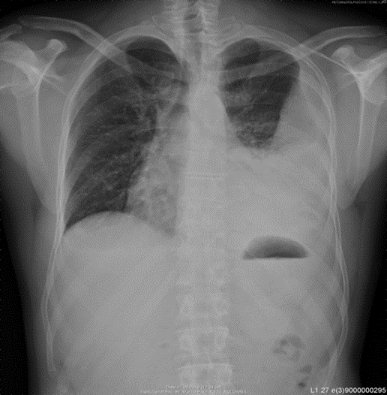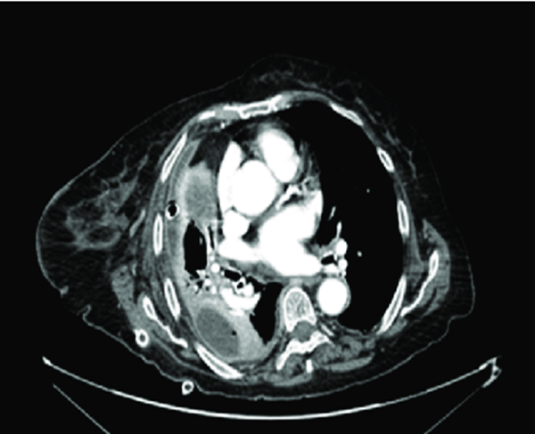

Fig. 2. Pleural empyema.

- The biportal approach also allows for the placement of the chest tube in the 6th-7th–8th intercostal spaces along the posterior axillary line (Fig. 3). This is particularly relevant for patients with effusions compared to those with anatomical resections or bullous emphysema and pneumothorax, where this might not be as critical.

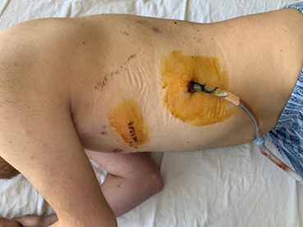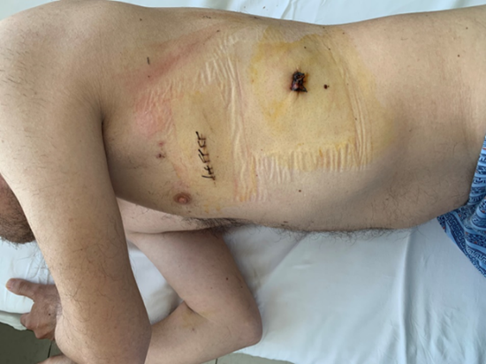

Fig. 3. Postoperative image after biportal VATS.

- The placement of the drain in a location other than the working port allows for better sealing, which is crucial in patients undergoing meticulous decortication (Fig. 4). This approach is particularly valuable in cases where a larger and more prolonged air leak can be expected, such as in patients with significant decortication needs or those with a thin chest wall or cachexia. The strategic positioning of the drain contributes to enhanced hermetic closure, optimizing the overall success of the procedure.

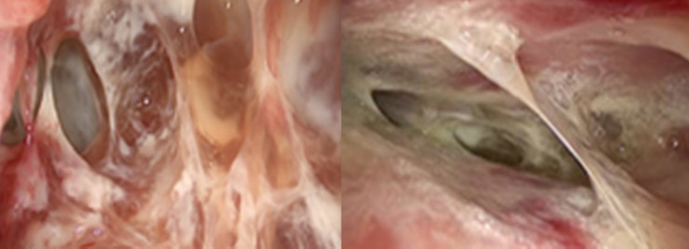

Fig. 4. Significant adhesions between visceral and parietal pleura requiring meticulous extensive decortication.

As significantly less important disadvantages compared to those of the other two operative methods, we note the following:

1. The operator has a different visual axis than the anatomical one, to which he is accustomed in open surgery.
2. There is a high potential risk of frequent collision of instruments and the camera when working in specific anatomical locations, especially when using the standard straight endoscopic instruments.
3. Significant increase in the cost of the procedure when using specific instrumentation.
In recent years, the trends towards increasingly minimally invasive techniques and the so-called less is more concept have gained much attention. With its introduction in 2010 by its founder Prof. Diego Gonzalez-Rivas, uniportal access has gained enormous popularity and has been implemented in more and more centers worldwide for the diagnosis and treatment of pulmonary diseases on a small and large scale, despite the more challenging technical and technological preparation it requires (4, 5).

The advantages of the method that we acknowledge overlap with those recommended by the pioneer of the technique, as well as with an increasing number of surgeons worldwide:

- Placing the camera and instruments parallel in one plane allows for easier adaptation of the surgeon to endoscopic work, increasing psychological comfort, especially when transitioning from open to thoracoscopic surgery. The operator’s position is most ergonomic, creating a natural eye-hand coordination, providing a favorable basis for easier technique acquisition.
- A significant reduction in pain syndrome is observed since the entire operation is performed through a single incision without the use of trocars, resulting in significantly reduced pain. There is practically no reason for intercostal damage, and silicone wound expanders, which do not damage the underlying tissues in any way, can be used for convenience. For patients with multiple comorbidities, even a minimal reduction in pain would provide a significant advantage in preventing postoperative atelectasis, pneumonia, or arrhythmias.
- There is reduced hospital stay associated with faster recovery and significantly fewer complications related to breathing sparing, postoperative stasis, and atelectatic changes, as well as early mobilization.
- It provides best cosmetic result compared to other thoracoscopic techniques.
- Since this approach requires extensive experience from practicing surgeons due to the greater complexity of maneuvering all instruments through a small incision, a lower incidence of cases with significant blood loss is expected.
- Reduced postoperative immunosuppression due to the shorter time under general anesthesia and intraoperative ventilation of the lungs is observed.
Unlike the two-port method, there are some serious disadvantages here, such as the expensive and specific instrumentation without which these operations are practically challenging or impossible. The remaining disadvantages include:

- Training requires attendance at specialized centers that teach and introduce individuals to the specialization in uniportal techniques, which extends and increases the cost of the learning curve.
- It is more challenging through the single incision of about 3–4 cm to insert more than a camera and 2–3 instruments. This is accompanied by difficulty in maneuvering, especially for inexperienced surgeons and those at the beginning of the learning curve.
- The technique is more challenging to apply in obese patients because the thick chest wall implies even more difficult maneuvering through the incision, and it also necessitates the use of even longer instruments.
- The commonly used 4th and 5th intercostal spaces for the incision are high for placing a drain in patients with pleural effusions, unlike those with anatomical resections or recurrent pneumothorax.
- Placing a drain through the operative opening sometimes hinders the proper sealing of the chest wall, especially in weak patients or those expected to have prolonged air leakage due to performed decortication or existing bronchopleural fistulas from other conditions.
- With localized effusions, it is sometimes quite challenging to reach certain anatomical zones.
- Performing thorough decortication in patients with fibrotic lungs or severe empyema with the formation of thick pleural adhesions requires the use of more instruments and manipulation of the lung, as well as periodic unfolding of the same, which prolongs and complicates the intervention when using only one operative opening.

In all our patients, faster recovery and shorter hospital stay were observed compared to those treated with open techniques, on average by 2–4 days, as their average hospital stay is 7–13 days. The shortest stay is observed in those with uniportal access (3 days), followed almost always by a similar number in two-port access, and the longest in those with multiport access when dealing with uncomplicated effusions. Naturally, there is a tendency for a longer stay (on average 3 to 9 days) in patients after decortication for empyema or with fibrotic lungs due to serious malignant involvement of the visceral pleura for all access types. A comparison between them shows that the hospital stay with multiport access is the longest, mainly because these patients are usually the most complex and complicated—with severe empyemas requiring extensive decortication, which is also the reason why more ports are used. It is precisely the decortication that leads to more cases with prolonged air leakage through the drain compared to the total number of cases operated with a specific access (22%), requiring later drain removal. For the other two methods, the data are relatively similar, with the duration being the shortest for two-port access due to the easier maneuvering through the working port in the absence of a camera and the possibility of using instruments through the second port when needed, especially in cases with a specific anatomical localization of the pleural locule. The complications we observed are minimal—one patient with new-onset arrhythmia, probably unrelated to the intervention, and one intraoperative bleeding from an intercostal vessel, necessitating conversion. All this is evidence that thoracoscopic approaches are applicable and safe, showing good results in terms of diagnostic and therapeutic value, as well as regarding possible recurrences, which we have not observed following such pleurodesis.

CONCLUSION
In conclusion, our results confirm data from numerous studies that thoracoscopic techniques are a method of choice in the diagnosis and treatment of pleural effusions. Different accesses offer a range of advantages and disadvantages for both the surgeon’s work and the patient. The choice of a specific access is an important and complex decision, the ultimate result of which should be in the name of achieving a personalized approach to each patient with the aim of achieving the most appropriate, safe, and rapid treatment.

REFERENCES:
- Bilgin et al. (63). Bilgin M, Akcali Y, Oguzkaya F. Benefits of early aggressive management of empyema thoracis. ANZ J Surg 2006;76:120-2.
- Bölükbas S, Eberlein M, Schirren J. Prospective study on functional results after lung-sparing radical pleurectomy in the management of malignant pleural mesothelioma. J Thorac Oncol 2012;7:900-5.
- Davies HE, Davies RJ, Davies CW, et al. Management of pleural infection in adults: British Thoracic Society Pleural Disease Guideline 2010. Thorax 2010;65:ii41-53.
- Evolving from conventional video-assisted thoracoscopic lobectomy to uniportal: the story behind the evolution Diego Gonzalez-Rivas1,2, Eva Fieira1, Maria Delgado1, Lucía Mendez1, Ricardo Fernandez1,2, Mercedes de la Torre1,2 Vol 6, Supplement 6 (October 2014): Journal of Thoracic Disease (Uniportal VATS) /
- Dr. Diego Gonzalez-Rivas: uniportal video-assisted thoracic surgery has become increasingly important J Vis Surg. 2016; 2: 113. Published online 2016 Jul 1. doi: 10.21037/jovs.2016.06.11
- Luh SP, Chou MC, Wang LS, et al. Video-assisted thoracoscopic surgery in the treatment of complicated parapneumonic effusions or empyemas: outcome of 234 patients. Chest 2005;127:1427-32.
- Perikleous P, Rathinam S, Waller DA. VATS and open chest surgery in diagnosis and treatment of benign pleural diseases. J Vis Surg. 2017;3:84. Published 2017 Jun 16. doi: 10.21037/jovs.2017.05.03
- Asian Pac J Cancer Prev. 2011;12(2):415-8. Video-assisted thoracoscopic surgery for malignant pleural effusions. Sayir F, Cobanoglu U, Mergan D, Demir H.
- Tacconi F, Pompeo E, Fabbi E, et al. Awake video-assisted pleural decortication for empyema thoracis. Eur J Cardiothorac Surg 2010;37:594-601.
- Venekamp LN, Velkeniers B, Noppen M. Does 'idiopathic pleuritis' exist? Natural history of non-specific pleuritis diagnosed after thoracoscopy. Respiration 2005;72:74-8.
- Wait MA, Sharma S, Hohn J, et al. A randomized trial of empyema therapy. Chest 1997;111:1548-51.
- Waller DA. Thoracoscopy in management of postpneumonic pleural infections. Curr Opin Pulm Med 2002;8:323.
- Wozniak CJ, Paull DE, Moezzi JE, et al. Choice of the first intervention is related to outcomes in the management of empyema. Ann Thorac Surg 2009;87:1525-30; discussion 1530-1.
- Zahid I, Routledge T, Billé A, et al. What is the best treatment of postpneumonectomy empyema? Interact Cardiovasc Thorac Surg 2011;12:260-4.

