Table 1. Patients’ demographics, clinical characteristics and operative technique.
 | Overall | Tumor size < 10 mm low-risk | Tumor size >10 mm high-risk
Age (median) | 65.2 | 58 | 72.1
Male / Female | 3 / 1 | 1 / 1 | 2 / 0
Bleeding | 4 | 2 | 2
Tenesmus | 3 | 1 | 2
Rectal mass | 1 | 0 | 1
Anal pain | 1 | 0 | 1
Anal discomfort | 2 | 1 | 1
TEM, full-thickness excision | 2 | 0 | 2
TEM, submucosal resection | 2 | 2 | 0

Table 2. Clinicopathological and surgical characteristics of patients with rectal carcinoid treated by TEM.
Case | 1 | 2 | 3 | 4
Age | 54 | 69 | 62 | 76
Sex | M | M | F | M
High/Low-risk | High-risk | High-risk | Low-risk | Low-risk
Location | Rb | Ra | Ra | Rs
Distance from the dentate line (cm) | 5 | 8 | 10 | 13
Size of primary tumor (mm) | 14 | 20 | 9 | 7
Depth of invasion | Submucosa | Muscularis propria | Submucosa | Mucosa
Lymphatic invasion | Absent | Absent | Absent | Absent
Vascular invasion | Absent | Absent | Absent | Absent
Operation time (min) | 45 | 55 | 27 | 33
Resection | R0 | R0 | R0 | R0
Follow-up (months) | 34 | 22 | 29 | 46

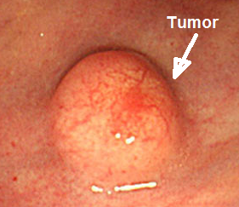
Fig. 1 Case 3. Carcinoid recti, sessile type (0-Is).
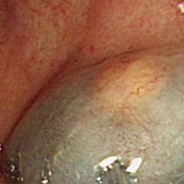
Fig. 2 Case 3. Injection into the submucosal plane.
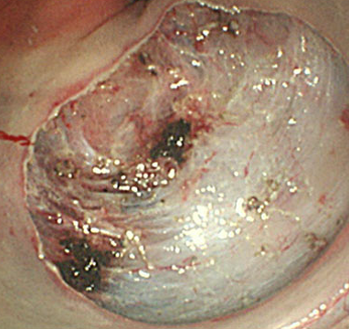
Fig. 3 Case 3. TEM, submucosal resection is completed.
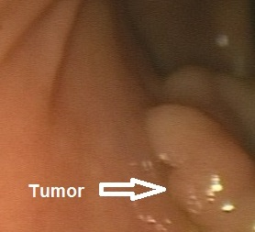
Fig. 4 Case 2. Carcinoid recti.
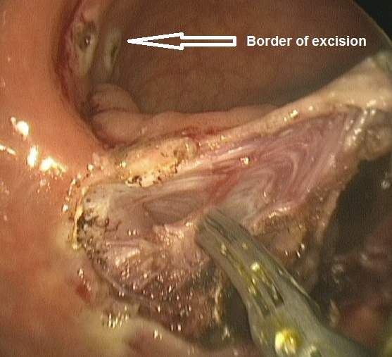
Fig. 5 Case 2. TEM, full-thickness excision.
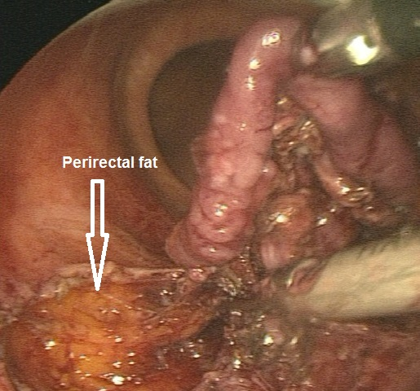
Fig. 6 Case 2. TEM, full-thickness excision.

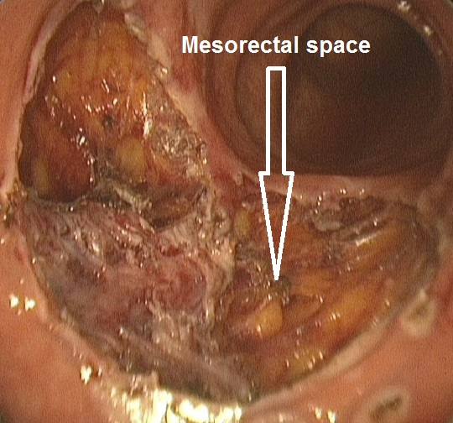
Fig. 7 Case 2. TEM, full-thickness excision is completed.
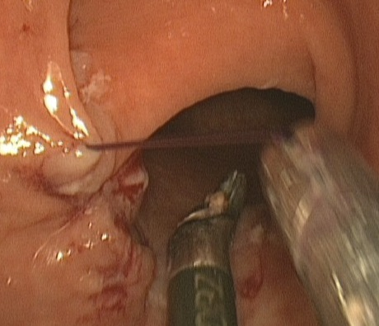
Fig. 8 Case 2. TEM, endoscopic suture of the rectal wall defect.
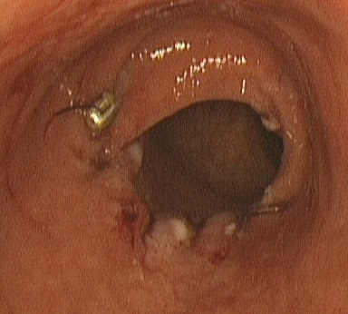
Fig. 9 Case 2. Final view after TEM full-thickness excision.
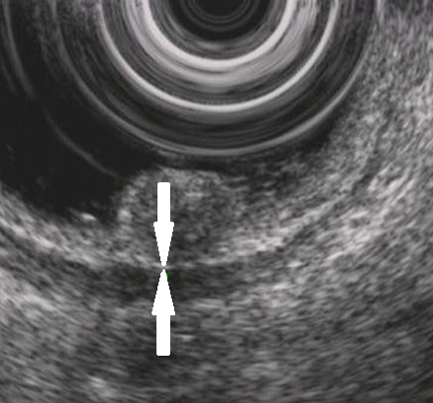
Fig. 10 Endoscopic ultrasound (EUS) on Case 3. Arrows shows submucosal layer, it is narrowed but not completely disrupted.

